EENG 385 - Electronic Devices and Circuits

BJT Curve Tracer: Calibration

Assembly Guide

# Assemble the BJT Curve Tracer

Congratulations, this week, you will complete soldering all the components needed for a functional BJT Curve Tracer in Figure 1. This includes all the components in the CURRENT MIRROR subsystem and the Q3 2N7000 MOSFET.

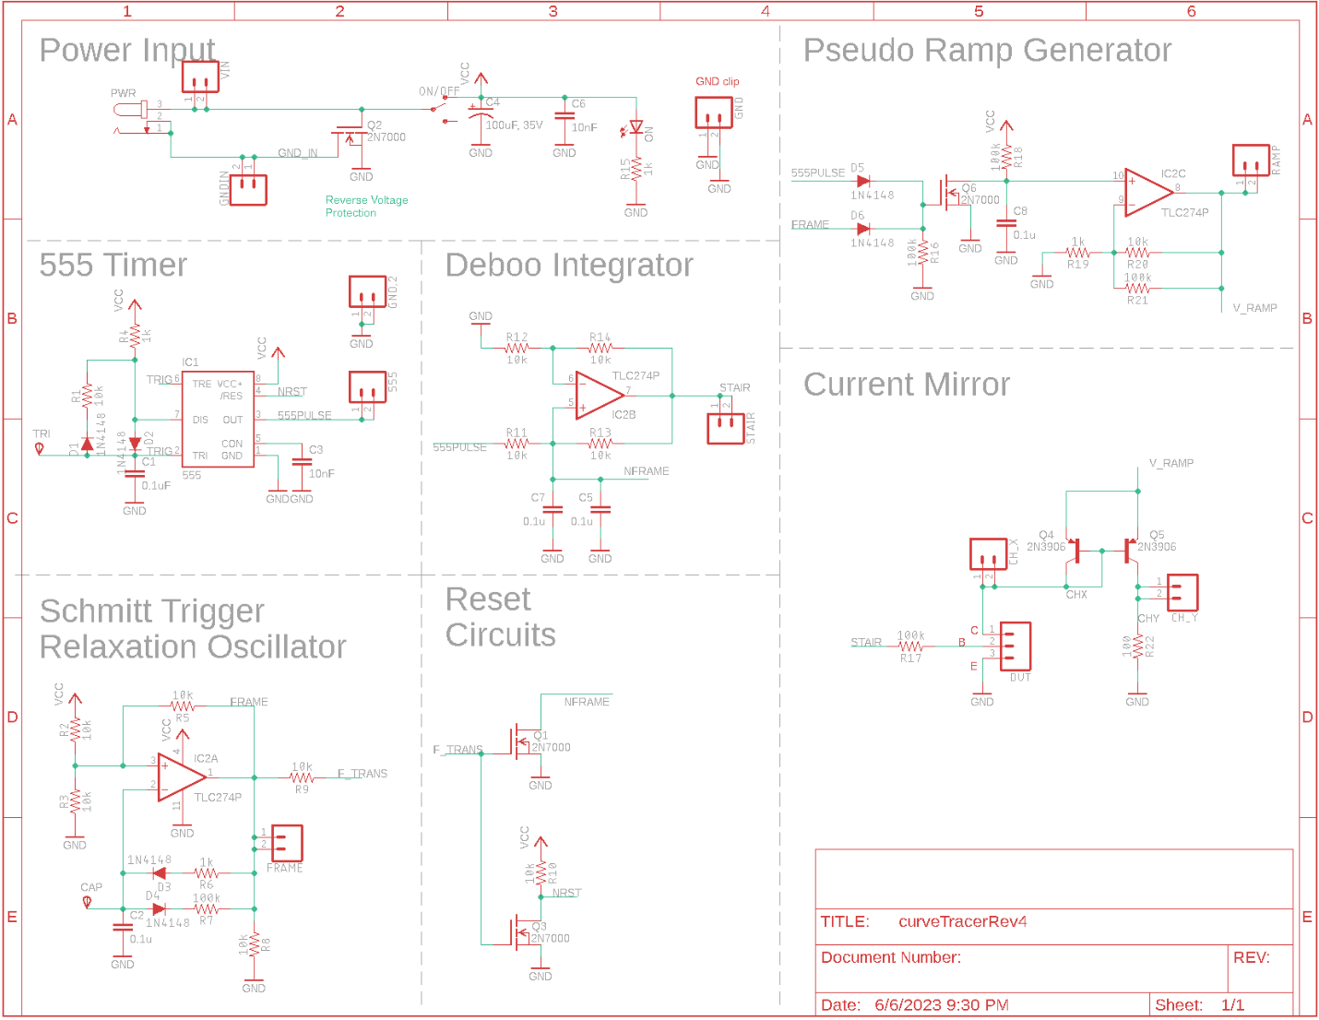

Figure 1: The schematic for the overall BJT curve tracer.

When complete your BJT Curve Tracer board should look like that shown in Figure 8.

* You will need two 2N3906 PNP transistors to populate the Q5 and Q6 positions. Make sure the flat side of the PNP package aligns with the flat side of the PCB silkscreen.
* You will need one 2N7000 to populate the Q3 position in the ST Relax Oscillator area. Make sure the flat side of the package aligns with the flat side of the PCB silkscreen.
* You will need to use the 3-pin header included in your parts bag for the DUT.
* Save the leads from your resistors to solder in the CH_X, XH_Y and GNG loops

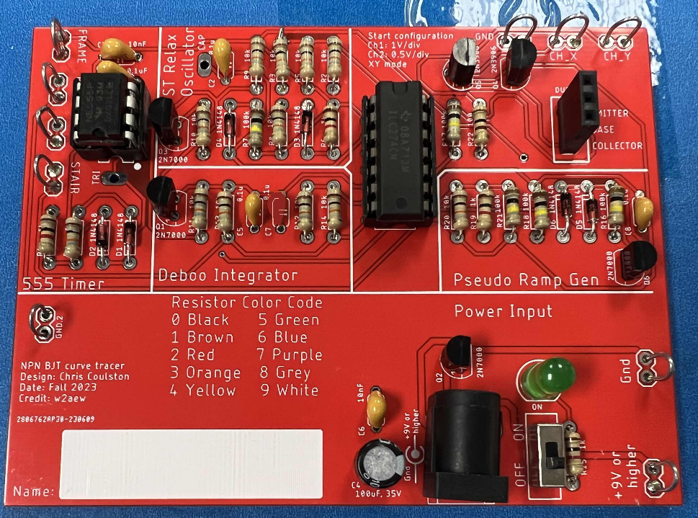

Figure : The completed BJT Curve Tracer board.

Now, test your completed BJT Curve Tracer using the procedures outlined in the lab and get some data!

# Tips For Top Performance

The BJT Curve Tracer is an important piece of electronics test equipment that you should be able to rely on to produce accurate and precise measurements. The Curve Tracer sitting on the desk in front of you is yours to keep, I hope that someday you can take pride in it being a part of your electronics workshop. If you take some extra time now with the following two items, you can significantly improve the accuracy and precision of the BJT Curve Tracer.

# 1) Measure the 100Ω and 100kΩ resistors with a DMM before installing them into the PCB. Use your measured values in the Vce and Ib tables.

# There are a couple of good reasons to do this. Since we are using 5% tolerance resistors, it is unlikely that the actual resistance matches the color banded value printed on the resistor. Also, it is never good idea to try to get a precise resistance value of a resistor when it is installed in a circuit because there could be components in parallel with the resistor that will effect the measured resistance.

2) Match the pair of PNP 2N3906 BJTs that form the current mirror in the output stage. We will consider BJTs to be matched when they have the same gain at 10uA. Note, 10uA is an arbitrary value, but representative of the current produced by the mirror. You can test the gain of a PNP transistor using the Peak Atlas DCA Pro that is available from the instructor. I’ve listed the gain of a few PNP transistors from our parts bin below to demonstrate the tremendous variation in gain.

For example, the two PNP BJTs resulted in

|  |  |  |
| --- | --- | --- |
| 2N3906 Marking |  | Gain at 10uA |
| 2N  3906  H 311 |  | 165 |
| F830  2N  3906 |  | 162 |
| S 3906 2N |  | 238 |
| 2N  3906  H 311 |  | 228 |
| 2N  3906  H 311 |  | 210 |

# Inserting the DUT into the BJT Curve Tracer

You will be measuring the performance of several BJTs in this week’s lab. In order to do so, you will have to insert the leads of the BJT into the correct socket positions as shown in Figure 9C. I orientated the DUT socket with the 2N3904 and 2N2222 BJTs in mind. To see how that effected the design, look closely at the arrangement of pins in Figure 9A and 7B. Even though the pins are arranged differently, the base is the center pin.

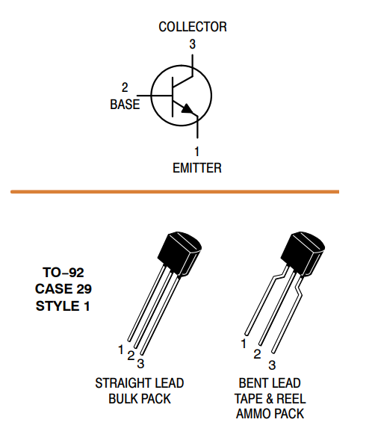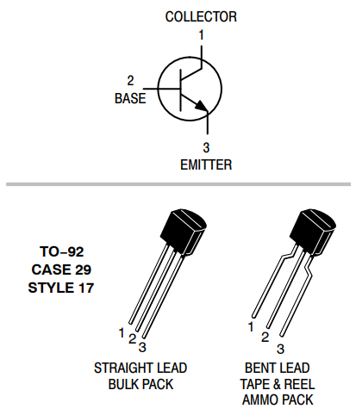 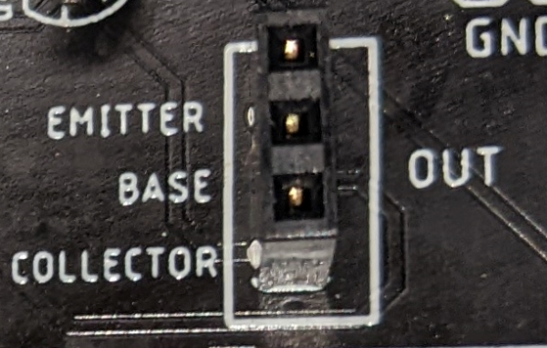

1. (B) (C)

Figure : (A) The datasheet for the 2N3904. (B) The datasheet for the 2N2222. (C) The socket for the DUT.

So you have to insert the 2N3904 into the DUT socket so that the BJT’s flat side is facing left. However, you have to insert the 2N2222 into the DUT socket so that the BJT’s flat side is facing right. You will not harm the test BJT if you put it in backwards.

The BJTs shown in Figure 9A and B are encased in JEDEC standard Transistor Outline Package Case Style 92 or TO-92 package. Most BJTs in a TO-92 package have the base as their center pin. This situation makes inserting them into the DUT socket a matter of trying two different orientations. The situation gets more complex for larger packages.

Before continuing, a note about BJT datasheets. Often BJTs are developed in complementary NPN/PNP pairs. For instance, Motorola designed 2N3904 and 2N3906 BJTs. Being designed as complementary pairs, the manufacturers often group the two complementary BJTs on the same datasheet for efficiency. When the manufacturer does this, you only need to look at the NPN device parameters datasheet because you will only be testing NPN devices in the BJT Curve Tracer.

Now, look at the datasheet for the BD139 and TIP41C shown in Figure 10A and 8B.

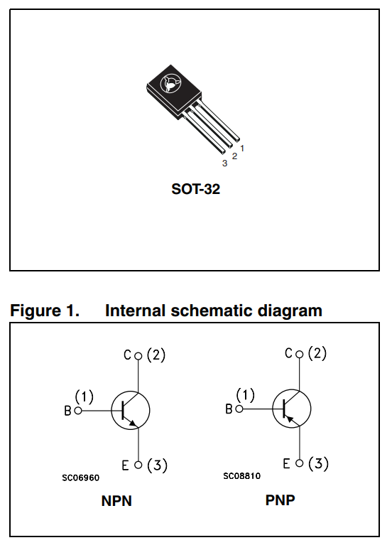 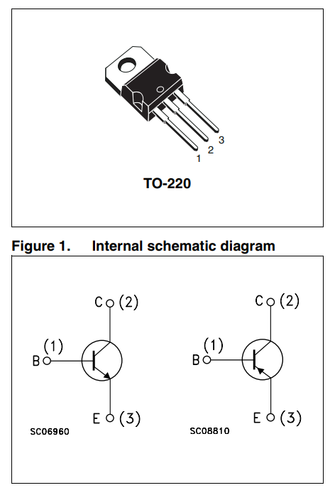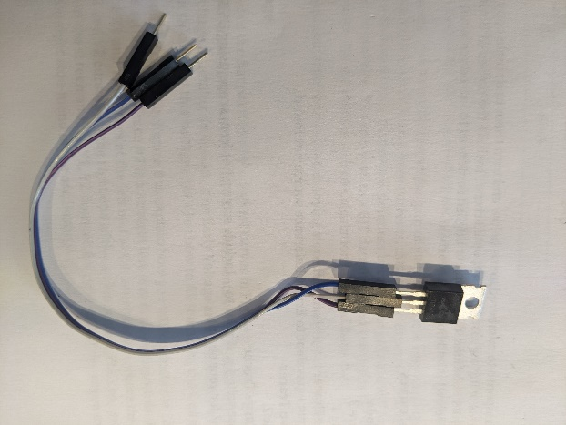

(A) (B) (C)

Figure : (A) The pinout for the BD139 (NPN) and BD140 (PNP). The pinout of the TIP41C (NPN) and TIP42C (PNP). You can use a set of jumper wires to adapt the pins of non-conforming devices to the DUT socket.

In Figure 10A, the NPN device in the Internal Schematic Diagram frame is called out as “NPN”. The base of the schematic symbol is denoted “B” with an accompanying number (1). Looking at the physical package above the schematic, the pin labeled “1” is the base, the rightmost pin on the BD139 when viewed from the front. In Figure 10B, the datasheet does not explicitly tell you which device is NPN, you need to look for its correct schematic symbol (SC06960). You should see the base is on the left side of the package when viewed from the front.

In both cases, you will need to reposition the BJT’s package leads before connecting it to the DUT socket on the BJT Curve Tracer. Do not bend the leads to accomplish this. By doing so, you risk breaking the leads, shorting the leads together, and making you look like a hack – a bad look. Instead, connect 3 male/female jumper wires as shown in Figure 10C to the BJT and then connect the male ends of the leads to the DUT socket.